**Project Planning Phase**

| Date | 14 April 2025 |
| --- | --- |
| Team ID | SWTID1743516636 |
| Project Name | SB Food Ordering App |
| Maximum Marks | 5 Marks |

**SPRINT - 1**

## Agile Sprint Breakdown for SB FOODS -FOOD ORDERING APP

## Epic: User Registration & Authentication

| **Task** | **Story** | **Story Points** | **Complexity** |
| --- | --- | --- | --- |
| Design registration page (email/password) | USN-1 | 2 | Easy |
| Implement user registration logic (API & DB connection) | USN-2 | 3 | Medium |
| Implement JWT-based Login & Session Handling | USN-3 | 2 | Medium |
| Design and develop the basic home page with restaurant list | USN-4 | 3 | Medium |

**Total Story Points (Sprint 1): 10**

Sprint 2 (5 Days)

**Epic: Order Placement & Checkout system**

| **Task** | **Story** | **Story Points** | **Complexity** |
| --- | --- | --- | --- |
| Implement Restaurant Menu Page | USN-5 | 4 | High |
| Add-to-Cart Functionality | USN-6 | 4 | High |
| Integrate Checkout and Payment Gateway | USN-7 | 2 | Medium |
| Apply Discount Coupons & Promo Codes | USN-8 | 2 | Medium |

**Project Tracker, Velocity & Burndown Chart: (4 Marks)**

## Project Tracker, Velocity & Burndown Chart

| **Sprint** | **Total Story Points** | **Duration** | **Sprint Start Date** | **Sprint End Date (Planned)** |
| --- | --- | --- | --- | --- |
|  |  |  |  |  |
| Sprint-1 | 20 | 6 Days | 01 Apr 2025 | 06 Apr 2025 |
| Sprint-2 | 22 | 6 Days | 07 Apr 2025 | 12 Apr 2025 |
| Sprint-3 | 22 | 6 Days | 14 Apr 2025 | 19 Apr 2025 |
| Sprint-4 | 22 | 6 Days | 21 Apr 2025 | 26 Apr 2025 |

**Sprint-1:** Focus on user registration, restaurant listing, and basic menu browsing.

**Sprint-2:** Implement cart functionality, item customization, and order placement.

**Sprint-3:** Integrate payment (Stripe), order tracking, and delivery module.

**Sprint-4:** Admin dashboard, performance optimization, and deployment

## Velocity Chart (Summary)

| **Sprint** | **Story Points Completed** |
| --- | --- |
| Sprint-1 | 20 |
| Sprint-2 | 19 |
| Sprint-3 | 17 |
| Sprint-4 | 22 |

Average Velocity=(20+19+17+22)/4​=19.5 Story Points per Sprint

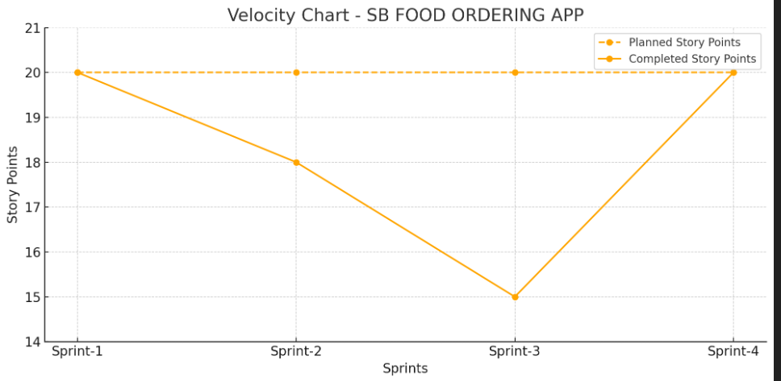

**Velocity:**

**Velocity Calculation**

Total Story Points = 10 (Sprint 1) + 12 (Sprint 2) = 22

No. of Sprints = 2

Velocity = Total Story Points / Number of Sprints

Velocity = 22 / 2 = 11 Story Points per Sprint

**Team’s velocity is 11 Story Points per Sprint**

**Burndown Chart:**

| DAY | PLANNING REMAINING POINTS | ACTUAL REMAINING POINTS |
| --- | --- | --- |
| DAY 1 | 20 | 20 |
| DAY 2 | 16 | 16 |
| DAY 3 | 12 | 13 |
| DAY 4 | 8 | 9 |
| DAY 5 | 4 | 5 |
| DAY 6 | 0 | 0 |

